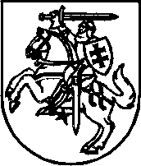

**MINISTER OF HEALTH PROTECTION OF THE REPUBLIC OF LITHUANIA**

**ORDER**

**ON NATIONAL PUBLIC HEALTH AND HEAT PREVENTION**

**APPROVAL OF THE 2016-2020 ACTION PLAN**

in 2015 December 9 No. V-1429

Vilnius

Pursuant to Article 46, Part 2 of the Law on the Health System of the Republic of Lithuania and implementing the inter-institutional action plan for the implementation of the goals and objectives of the National Climate Change Management Policy Strategy, approved by the Government of the Republic of Lithuania in 2013. April 23 by resolution no. 366 "On the approval of the inter-institutional activity plan for the implementation of the goals and objectives of the National Climate Change Management Policy Strategy", provisions:

1. I am attaching the National Action Plan for Public Health and Heat Prevention 2016-2020 (attached).

2. I entrust the execution of the order to the deputy minister according to the field of activity.

Minister of Health Rimantė Šalaševičiūtė

CONFIRMED

of the Minister of Health Protection of the Republic of Lithuania in 2015 December 9

by order no. V-1429

**NATIONAL PUBLIC HEALTH AND HEAT PREVENTION**

**2016-2020 ACTION PLAN**

**I SECTION**

**BENDROSIOS NUOSTATOS**

1. The purpose of the National Action Plan for Public Health and Heat Prevention (hereinafter - the Action Plan) is to protect the health of the population and especially heat-sensitive people from the negative effects caused by heat by increasing public awareness, initiating and promoting inter-institutional cooperation.

2. The action plan implements and complements:

2.1. National policy strategy for climate change management, approved by the Seimas of the Republic of Lithuania in 2012. November 6 by resolution no. XI-2375 "On approval of the National Climate Change Management Policy Strategy";

2.2. 2014-2020 national progress program, approved by the Government of the Republic of Lithuania in 2012 November 28 by resolution no. 1482 "On approval of the national progress program for 2014-2020";

2.3. other strategic planning documents contributing to the creation of a complex environment for good public health and to ensure the continuity of climate change policy on health issues.

3. In order to achieve the goal of the action plan, the planned measures will help inform the public and heat-sensitive people about the health risks caused by heat more efficiently; improve inter-institutional cooperation by establishing a heat prevention working group; based on the results of scientific research and work, to provide the public, heat-sensitive people and specialists with scientifically based information about the effects of heat on health.

4. The provisions of the action plan are based on the best practices of European countries and the value system of the new health policy "Health 2020" of the European Regional Office of the World Health Organization (hereinafter - WHO).

5. The action plan's target population groups that are sensitive to heat include:

5.1. Elderly people (especially over 75);

5.2. People who have had or are suffering from chronic diseases in the past. The list of diseases whose course can be affected by heat is given in Chapter II of the Action Plan;

5.3. People who are more difficult to adapt to the heat (infants and children under 18 years of age, single (living alone) people, pregnant women, people who are overweight, have severe physical or mental illness, people who are constantly taking medication, people with lower incomes, urban residents (especially those living on the upper floors of buildings and/or buildings with south-facing windows);

5.4. Persons who are more exposed to negative environmental factors (working in conditions of increased heat exposure (outdoors, foundries, bakeries, etc.), persons of social risk groups (consumers of alcohol, narcotic substances, without permanent residence, living outdoors, etc.).

6. Terms used in the Action Plan:

6.1. **Heat** is a dangerous meteorological phenomenon when the highest air temperature is + 30 °C and higher; duration - 1-2 days.

6.2. **Heat wave** - a natural meteorological phenomenon, when the highest air temperature is + 30 °C and higher; duration – 3 or more days.

7. Action plan implementation tasks, measures, execution deadlines and executors are presented in Annex 1 of the Action Plan.

**IISECTION**

**SITUACIJOS APŽVALGA**

8. Each of the past three decades has been hotter on Earth's surface than any since 1850. (Figure 1).

**Figure 1** . Deviation of global mean ocean and land temperatures 1850–2012. (left) and average temperature anomalies in Vilnius between 1850 and 2012. (on the right).

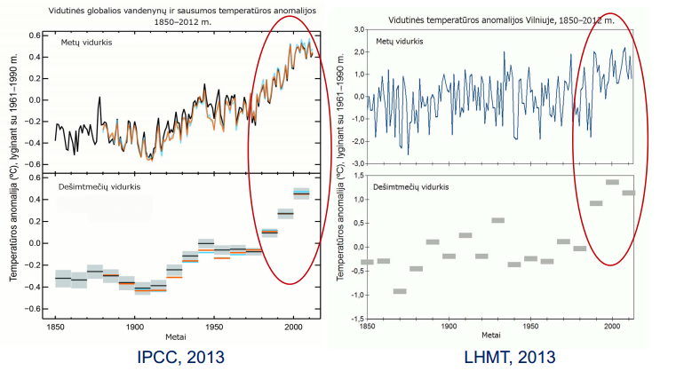

9. The climate of Lithuania is transitional, between mild maritime Western Europe and continental Eastern Europe. The average annual air temperature in Lithuania is 6.9 °C (it varies from 6.1 °C to 8.0 °C in various parts of the country). The coldest month of the year is January, and February is more often at the seaside, July is the warmest, August is at the seaside. On average, 590-910 mm of precipitation falls on the territory of the country per year .   
With the onset of climate warming, and especially in this century, the cold period of the year has warmed more than the warm period. Spring months have become warmer, July is much warmer, heat is often observed. The number of hot days increased 3 times (Figure 2).

**Figure 2** Recurrence of hot days with an air temperature of +30 °C and higher in Klaipėda and Vilnius, 1961–2015. (Lithuanian hydrometeorological service under the Ministry of the Environment, 2015).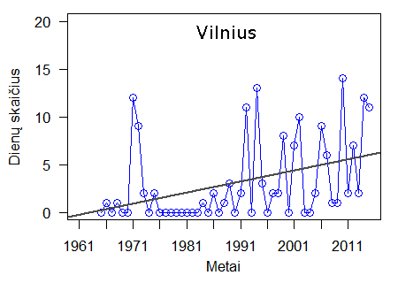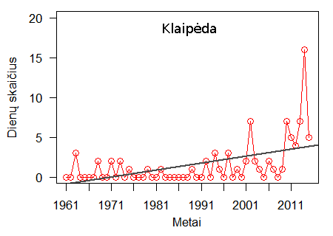

10. Global climate change processes will inevitably affect Lithuania's climate as well. According to the report prepared and presented by the European Environmental Protection Agency, Lithuania is in that part of Central and Eastern Europe, which is threatened by extreme high temperature events, changes in water temperature, forest fire risks, decrease of precipitation in summer and decrease of the economic value of the forest due to climate change.

11. As the world climate changes, the periodic change and monitoring of natural (external) factors is a key condition to determine their links with various health problems.

12. People's health is affected by the environment, weather and climate conditions around them, and as the climate changes, the range of new challenges to public health only increases. The interaction between climate change and human health is complex and depends on other factors operating in the residential area, the demographic situation, the health conditions of the population and the supply of health services. Even if the effects of climate change are felt globally, the level of impact varies from region to region.

13. The body's resistance to climate factors depends on the frequency and intensity of their impact. This is especially relevant in the initial stage of the disease. Later, the influence gradually decreases, as the human body has the ability to adapt to external influences.

14. According to the study conducted by UAB Infraplano, which identifies the threats to human health posed by climate change, the dependence of certain diseases and other public health consequences on heat has been established. According to the International Statistical Classification of Diseases and Health Disorders (tenth edition), heat depends on:

14.1. circulatory system diseases (I00-I99);

14.2. diseases of the respiratory system (J00-J99);

14.3. kidney diseases (N00-N99);

14.4. mental and behavioral disorders (F00-F29);

14.5. diabetes mellitus (E10-E14);

14.6. drownings (W65-W74);

14.7. intestinal infections (A00-A09);

14.8. heat stroke (T67.0);

14.9. skin diseases (L00-L99);

14.10. eye sensitivity (H00-H06);

14.11. malignant tumors of the skin (C40-C43);

14.12. sunburn (L55-L55.9);

14.13. other acute skin lesions caused by ultraviolet rays;

14.14. burns (of various degrees; T20-T31);

14.15. diseases caused by parasites: fascioliasis (B66.3);

14.16. hepatitis A (B15).

15. The negative effects of heat on health are observed during the entire heat wave, the number of deaths increases by about 15 percent already on the second day of the heat wave. A heat wave lasting longer than 5 days causes 1.5 to 5 times more negative health effects than a shorter one lasting up to 5 days. The risk of mortality increases from 0.2 to 5.5 percent. with each additional degree Celsius of temperature rising above the region-specific temperature limit.

16. As the climate changes and temperatures rise, increasing levels of ozone in the lower troposphere irritate the respiratory tract, leading to the development of chronic lung diseases, increased hospitalizations and increased mortality. Each degree Celsius above the long-term average increases the risk of premature death by up to 6 times in patients with respiratory diseases compared to the general population.

17. The effects of heat on human health are exacerbated by high daytime highs and nighttime lows. In Lithuania, nights with the lowest air temperature higher than +18 °C occur only in the summer months, usually in July. It was established that during the period 1961-2015, the number of such nights increased, especially in the months of July and August.

18. Meteorological factors and their adverse health combinations have a pronounced seasonal effect on multiple sclerosis patients.

19. A seasonal increase in the incidence of acute myocardial infarction was found in March-May and September-November.

20. There is a clear link between meteorological factors and various behavioral and psychiatric disorders. Despite many studies demonstrating sensitivity to weather, there is still a lack of research revealing the causal relationships between these interactions. It has been established that the following meteorological factors are usually related to well-being: temperature, length of daylight, sunny hours, relative air humidity, atmospheric pressure. Psychiatric hospitalizations and suicides increase in the spring and summer, especially when temperatures fluctuate.

21. People with diseases such as diabetes are more vulnerable to adverse effects of climate than others. They have a higher risk of dehydration, heart attack and other vascular diseases, especially in high temperatures.

**IIISECTION**

**VEIKSMŲ PLANO TIKSLAS IR UŽDAVINIAI**

22. The purpose of the implementation of the action plan is to protect the health of the population from the effects of heat and to increase public awareness of the dangers of heat in order to protect people who are sensitive to heat.

23. Action plan implementation tasks:

23.1. Reduce the negative effects of heat on public health by increasing awareness of people who are sensitive to heat.

23.2. Ensure and promote close cooperation of national, regional, local level institutions and legal entities on public health and heat issues in order to improve information for people who are sensitive to heat.

**IVSECTION**

**SIEKIAMI REZULTATAI**

24. The population's health was more effectively protected from the effects of heat and public awareness of the dangers of heat was increased.

**VSECTION**

**VEIKSMŲ PLANO ĮGYVENDINIMAS**

25. The implementation of the action plan is coordinated by the Ministry of Health.

26. In the implementation of the Action Plan, the Ministries of Health Protection, the Ministry of the Environment, institutions and bodies under the Government of the Republic of Lithuania are involved, as well as municipal institutions and other institutions according to competence, business enterprises, non-governmental organizations, media and communities.

27. The measures provided for in the action plan are implemented from the general appropriations allocated to the relevant institutions and the funds received in accordance with other legal acts.

28. The evaluation criteria for the implementation of the Action Plan are specified in Annex 2 of the Action Plan.

**VISECTION**

**BAIGIAMOSIOS NUOSTATOS IR ATSKAITOMYBĖ**

29. State institutions participating in the implementation of the Action Plan provide the Health Education and Disease Prevention Center with information on the implementation of the Action Plan measures by January 15 of each year. The Center for Health Education and Disease Prevention provides summarized information on the implementation of the Action Plan to the Ministry of Health by   
January 31 of each year.

________________________________

National Public Health and Heat

prevention 2016-2020 action plan

Appendix 1

**TASKS, MEASURES, IMPLEMENTATION DEADLINES AND EXECUTORS OF THE NATIONAL PUBLIC HEALTH AND HEAT PREVENTION 2016-2020 ACTION PLAN**

|  |  |  |  |  |
| --- | --- | --- | --- | --- |
| **Row No.** | **Tasks** | **Means** | **Execution term** | **Responsible executors** |
|
| 1. | Reduce the negative effects of heat on public health by increasing awareness of people who are sensitive to heat | 1.1. Prepared by the Minister of Health Protection of the Republic of Lithuania and the Minister of the Environment of the Republic of Lithuania in 2012. May 3 order no. V-386/D1-391 "Regarding the approval of the description of the system for informing the public about climate change and threats to human health" in order to ensure public information about heat and heat | 2017 | Center for Health Education and Disease Prevention, Ministry of Environment |
| 1.2. Prepare recommendations for companies on preventive measures to protect employees depending on the nature of work | 2017 | Institute of Hygiene |
| 1.3. Prepare recommendations for pre-school educational institutions in order to protect children from the effects of heat | 2018 | Center for Health Education and Disease Prevention |
| 1.4. Prepare recommendations on how to protect people who are sensitive to heat | 2016 | Center for Health Education and Disease Prevention |
| 1.5. Prepare a description of the procedure for providing emergency aid to heat-sensitive people during heat and heat | 2017 | Center for Health Education and Disease Prevention |
| 1.6. Prepare questionnaires for institutions and population groups in order to assess their preparedness for the coming heat | 2017 | Center for Health Education and Disease Prevention |
| 1.7. Prepare informational tools about the effects of heat and heat and places where you can get help if you feel the negative effects of heat and distribute them in personal health and public health care institutions, educational and training institutions, public spaces in cities and during mass events | 2017-2020 | Center for health education and disease prevention, municipalities |
| 1.8. Continuously inform the public and health care professionals about approaching heat and measures to protect against the adverse effects of heat, before and during predicted heat | 2016-2020 | Center for Health Education and Disease Prevention, Lithuanian Hydrometeorological Service under the Ministry of Environment |
| 1.9. Inform the public and responsible institutions about the effects of heat on mortality and morbidity | 2016-2020 | Center for Health Education and Disease Prevention |
| 1.10. To supplement the recommendations for the preparation of emergency management plans of personal health care institutions with provisions on measures that help reduce the effects of heat and protect the health of patients and employees in personal health care institutions | 2017 | Center for extreme health situations |
| 1.11. Organize a seminar on the prevention of heat effects for public health specialists | 2018 | Center for Health Education and Disease Prevention |
| 2. | Ensure and promote close cooperation between national, regional, local level institutions and legal entities on public health and heat issues in order to improve information for heat-sensitive people | 2.1. Initiate the creation of an interdepartmental working group for the prevention of the effects of heat, in order to properly prepare for potential heat and heat and the health threats they pose every year | 2016 | Center for Health Education and Disease Prevention |
| 2.2. Prepare an annual analysis to assess the effects of heat on the health of Lithuanian residents | 2016-2020 | Institute of Hygiene |
| 2.3. To organize a health knowledge assessment competition "Climate change and health" aimed at assessing residents' knowledge about the effects of heat on health | 2017 | Center for health education and disease prevention, municipalities |

________________________________

National Public Health and Heat

prevention 2016-2020 action plan

Appendix 2

**NATIONAL PUBLIC HEALTH AND HEAT PREVENTION 2016-2020 ACTION PLAN**

**IMPLEMENTATION ASSESSMENT CRITERIA**

|  |  |  |  |  |  |  |  |
| --- | --- | --- | --- | --- | --- | --- | --- |
| **Task, tool** | **Evaluation criteria** | **Evaluation criteria values** | | | | | **Responsible executors** |
| **in 2016** | **in 2017** | **in 2018** | **in 2019** | **in 2020** |
| 1. To reduce the negative impact of heat on public health by increasing the awareness of people who are sensitive to heat | 1.1.–1.11. number of information measures implemented (units) | 3 | 12 | 6 | 4 | 4 | Center for Health Education and Disease Prevention, Ministry of the Environment, Institute of Hygiene, Lithuanian Hydrometeorological Service under the Ministry of the Environment, Center for Extreme Health Situations, municipalities |
| 2. To ensure and promote close cooperation of national, regional, local level institutions and legal entities on public health and heat issues in order to improve information for heat-sensitive people | 2.1-2.3. number of implemented cooperation measures (units) | 2 | 2 | 1 | 1 | 1 | Center for health education and disease prevention, Institute of Hygiene, municipalities |

________________________________